Goalball Clinic
A game for the blind, visually impaired, their families, and friends!


CBCB

Goalball is a game played on your hands and knees on a gym floor. Since this is a game to be played without sight, everyone is required to wear a blindfold. The goalball has bells in it so players can hear the ball. There are 3 players on each team. The object of the game is to score points by rolling the ball across your goal line which is guarded by the opposing team. You must be 5 years or older to play. Players will be grouped according to their ages and the game will be modified for younger players.

PLACE: Titustown Recreation Center,
7545 Diven Street, Norfolk, VA

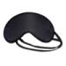
DAY: Saturday, November 11, 2006

TIME: 10:00 a.m. – 2:00 p.m.

COST: Free. Refreshments and lunch will be provided.

Sponsored by:
Norfolk Therapeutic Recreation Center
and the
Chesapeake Bay Chapter of the Blind, NFBV

This is the first Goalball Clinic in the Hampton Roads area. Don’t miss out on this exciting event. Come ready to play and have lots of fun. Even if you don’t know how to play, your support and enthusiasm are welcome.

http://www.britishblindsport.org.uk/goalball.htm 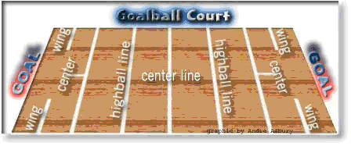

For registration and further information contact:
Jessie Olds, 757-428-8035
or visit www.cbcbvi.org

